Noun as an Object Complement

✅ What Is a Noun as an Object Complement?
# Source: AI Source: Provided by: [Data Path: Persons Table -> ID Column: 1, Name_En Column: Motasem Essam] -> From: [ChatGPT] on [8/4/2025]
A noun used as an object complement renames, identifies, or classifies the direct object of a verb. It completes the idea of the sentence by telling what the object becomes or what it is called after the action is done.

🔸 Key Features:
# Source: AI Source: Provided by: [Data Path: Persons Table -> ID Column: 1, Name_En Column: Motasem Essam] -> From: [ChatGPT] on [8/4/2025]
- Comes after the direct object
- Always a noun or noun phrase
- Gives the object a new identity or role
- Used with verbs of calling, naming, making, choosing, electing, etc.

🔸 Examples of Noun Object Complements:
# Source: AI Source: Provided by: [Data Path: Persons Table -> ID Column: 1, Name_En Column: Motasem Essam] -> From: [ChatGPT] on [8/4/2025]
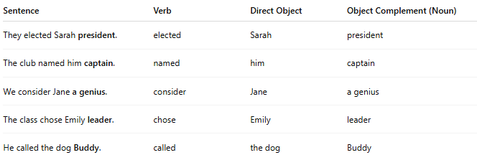
Sentence | Verb | Direct Object | Object Complement (Noun)
They elected Sarah president. | elected | Sarah | president
The club named him captain. | named | him | captain
We consider Jane a genius. | consider | Jane | a genius
The class chose Emily leader. | chose | Emily | leader
He called the dog Buddy. | called | the dog | Buddy

🔸 How to Identify:
# Source: AI Source: Provided by: [Data Path: Persons Table -> ID Column: 1, Name_En Column: Motasem Essam] -> From: [ChatGPT] on [8/4/2025]
Ask:
- What did they elect Sarah? → President
- What did they call the dog? → Buddy
If the word after the object renames it and makes sense with “as,” it’s likely a noun object complement:
➡ They elected Sarah as president ✅

